Exchange Server 2013 Configuration

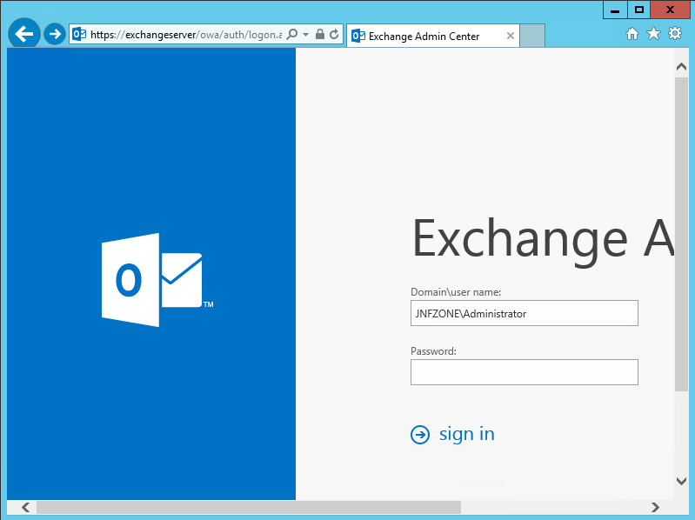

First, log into the exchange server via web console.

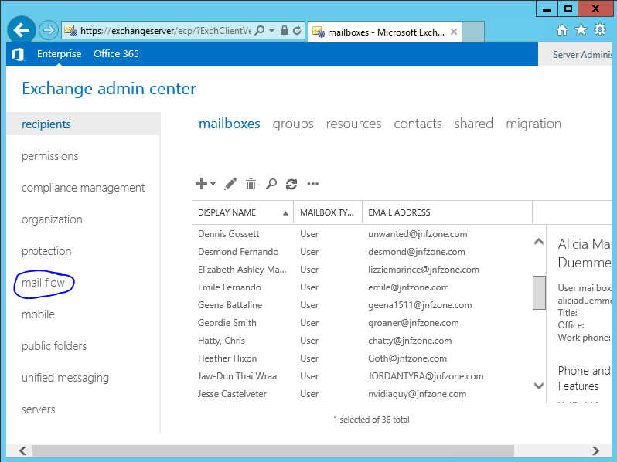

Second, go to the Mail Flow link on the left side.
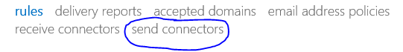
Third, go to “Send Connectors”.

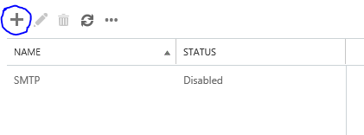
Fourth, click on the plus sign to add an SMTP Relay.

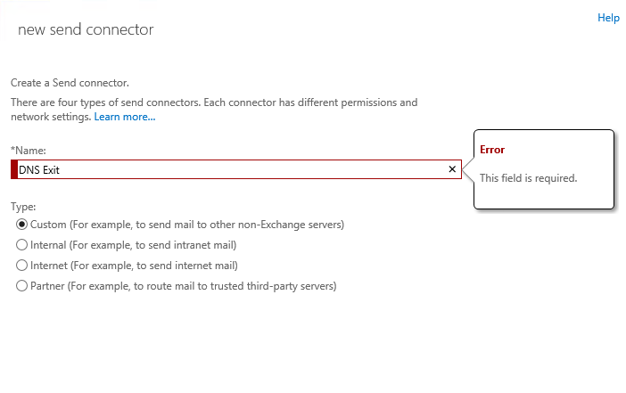
Fifth, Type in the name of your DNS Exit send connector.

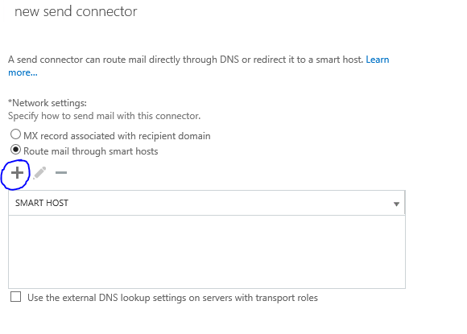
Six, choose “Route mail through smart hosts and then click the plus sign.

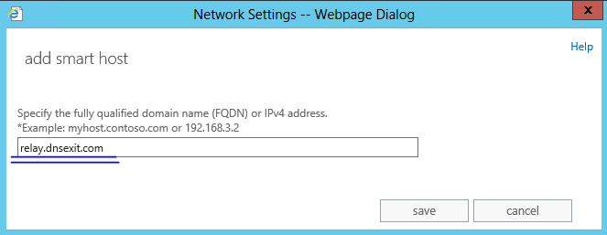

Seven, type in “relay.dnsexit.com” and then click save. Click next and leave the external DNS blank.

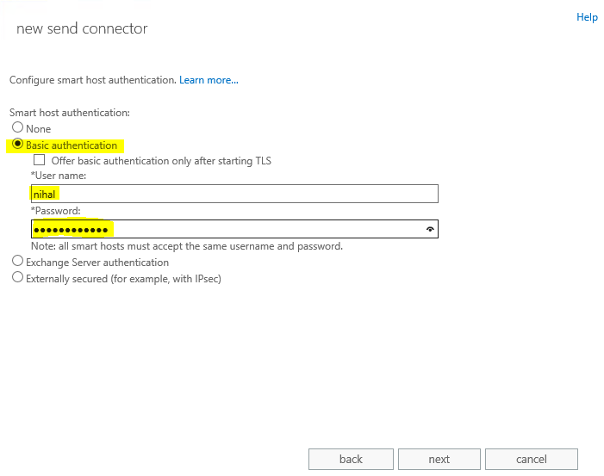
Eight, select “Basic authentication” and type in your username and password configured for smarthost. Click next.
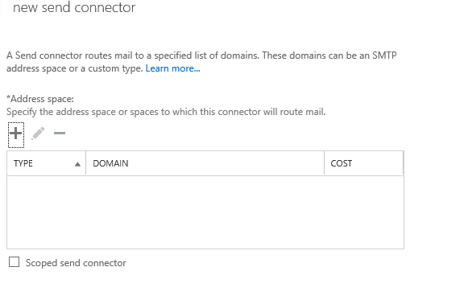
Nine, click the plus sign.
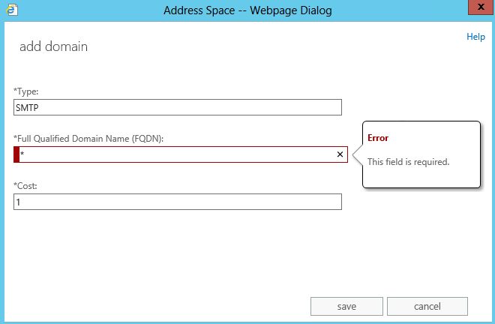
Type an Astrisks for the FQDN and then click save. Leave the Scoped sender send connector unchecked.
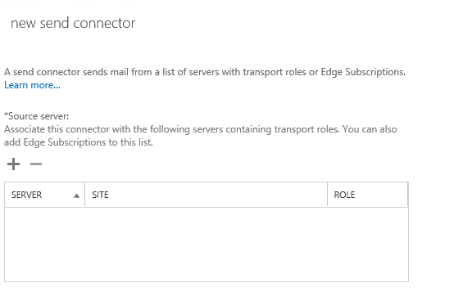
Select the plus sign again and add the exchange server which you will be using.
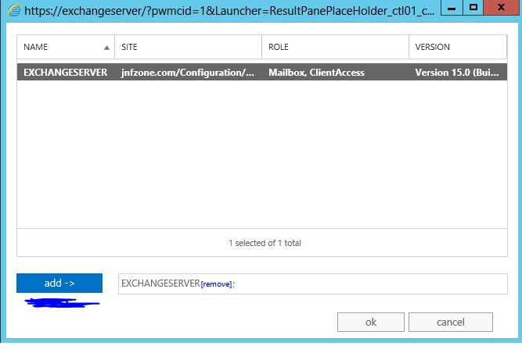
Click on Finish and you are done.

EXTRA STEP:

If port 25 is blocked, then you will need to do this.

In the start menu (or start screen) go to the Exchange Management Shell:

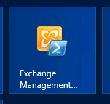

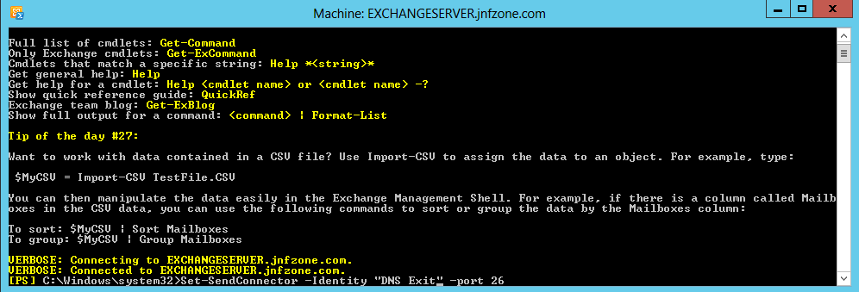
You will then need to type in this:
Set-SendConnector -Identity "SENDCONNECTORNAME" -port 26

Where SENDCONNECTORNAME is the name of the send connector which you named in Step 1 and port 26 could be port 8001 or 2525.
If nothing reports, then it worked.

